County's fallen servicemen get memorial
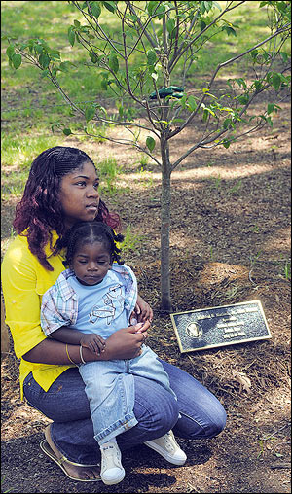
Photo by Andy Carruthers - The Capital

Plaque dedicated, nine dogwoods planted at Fort Smallwood Park
By ALLISON BOURG, Staff Writer
Published May 18, 2008
Army Spec. Michael B. Matlock Jr. always wanted to serve his country.
"He talked about it a lot," his widow, Breon, said yesterday.

Spec. Matlock, 21, was killed by an explosion in Iraq three months ago, leaving her to raise their 17-month-old son, Byron. "He always said he was going to do something big. So he did something big."
The Glen Burnie High School graduate was one of nine fallen soldiers honored yesterday at Fort Smallwood Park on Armed Forces Day.
The county has planted a grove of nine red dogwood trees at the historic park in memory of the Anne Arundel servicemen who lost their lives in the war on terror.
County Executive John R. Leopold also dedicated a 90-foot flagpole and a plaque bearing the men's names.
Those honored included Sgt. 1st Class James J. Stoddard of Crofton, Cpl. Justin J. Watts of Crownsville, Staff Sgt. Christopher W. Swanson of Rose Haven, Pfc. Eric M. Kavanagh of Glen Burnie, Lance Cpl. Eric W. Herzberg of Severna Park, Command Sgt. Maj. Roger W. Haller of Annapolis, Maj. Douglas A. Zembiec of Annapolis, Spec. Matlock of Glen Burnie and Sgt. 1st Class Collin J. Bowen of Millersville.
"These men were and always will be members of our armed forces," said Kenneth McCall Sr., the county's commissioner of Veterans Affairs. He was joined at the ceremony by Mr. Leopold and Col. Kenneth O. McCreedy, installation commander of Fort George G. Meade. "Freedom is not free, and that cost is paid too often by sacrificing lives."
About 200 guests, most family members and friends, wiped tears from their eyes as officials raised a 35-foot by 20-foot American flag up the pole, where it waved in the gentle breeze coming off the Patapsco River.
The flag has 45 stars, representing the number of states in the union when Fort Smallwood was constructed in 1899, said Frank Marzucco, director of the county's Recreation and Parks Department.
It will be flown at half staff for the first 24 hours as a tribute to the fallen servicemen.
Tiffany Matlock, Spec. Matlock's older sister, said through tears that her brother would have loved it.
"He was kind of a show-off," the 25-year-old said with a laugh. "He would have been proud."
After a brief ceremony, families gathered around the newly planted trees. Some stood in silence, remembering their loves ones, while others wept and held each other.
Sgt. Stoddard "loved his job, loved the Army," recalled his widow, Amy Stoddard of Crofton. He died during his second tour of Afghanistan in September 2005, when he was thrown from his Humvee after it skidded into a ditch. Sgt. Stoddard also served in Iraq.
"I think he would have liked this," Mrs. Stoddard said of the memorial, the first of its kind in the county. "Although he'd probably say he was just doing his job."
Mrs. Stoddard said her husband, whose family has a long history of military service, tried to shield her and their three children from the reality of war. But he knew there was a chance he could be killed in the line of duty, she said.
"But he never really talked about it," said Mrs. Stoddard, who wore a pin with her husband's picture on it to the ceremony. "He didn't want me to worry and be scared to death."
Sgt. Stoddard was the second Anne Arundel soldier to die in the war. The first was Marine Cpl. Jason Mileo, who was killed in Iraq in April 2003 after being mistaken for an enemy soldier. He grew up in Pasadena, but lived on the Eastern Shore at the time of his death.
He was not included in the memorial because his military home of record was listed as Centreville.
Sue Bents of Crofton, who sits on the park's advisory council, was at the ceremony in honor of another veteran - her father. A World War II veteran, he passed away recently at age 89, she said.
The 100-acre park once held one of the forts that guarded the approach to Baltimore, and a battery and barracks building still are on the property. It's the perfect place for a war memorial, Ms. Bents said.
"With its history, it just seemed right," she said.

